**1. SYSTEM REQUIREMENTS SPECIFICATION**

**Hardware Requirements**

# Processor : INTEL CORE I7-7020U

Speed : 2.3 GHz

RAM : 4GB DDR4

Hard Disk : 1 TB

**Software Requirements**

Operating System : WINDOWS 10

Front End : HTML & CSS

Database Server : NULL

**2.About :**

The aim of E-Krushi is more efficient agriculture, safe harvesting and getting higher yields by digitalized farming.

The main objective of this project is to give pace to the growth rate of agriculture development and crop production and productivity which will strengthen the economic status of the farmer and uplift their lifestyle. In addition to this, the objective of the department is to implement suitable scheme for removal of regional disparity and employment generation.

|  |  |  |  |
| --- | --- | --- | --- |
| **TAGS** | **DESCRIPTION** | **TAGS** | **DESCRIPTION** |
| [<html>](https://www.w3schools.com/tags/tag_html.asp) | Defines an HTML document | [<center>](https://www.w3schools.com/tags/tag_center.asp) | Not supported in HTML5. Use CSS instead. Defines centered text |
| [<head>](https://www.w3schools.com/tags/tag_head.asp) | Defines information about the document | [<font>](https://www.w3schools.com/tags/tag_font.asp) | Not supported in HTML5. Use CSS instead. Defines font, color, and size for text |
| [<title>](https://www.w3schools.com/tags/tag_title.asp) | Defines a title for the document | [<pre>](https://www.w3schools.com/tags/tag_pre.asp) | Defines preformatted text |
| [<body>](https://www.w3schools.com/tags/tag_body.asp) | Defines the document's body | [<u>](https://www.w3schools.com/tags/tag_u.asp) | Defines text that should be stylistically different from normal text |
| [<h1> to <h6>](https://www.w3schools.com/tags/tag_hn.asp) | Defines HTML headings | [<form>](https://www.w3schools.com/tags/tag_form.asp) | Defines an HTML form for user input |
| [<p>](https://www.w3schools.com/tags/tag_p.asp) | Defines a paragraph | [<input>](https://www.w3schools.com/tags/tag_input.asp) | Defines an input control |

**4.HTML TAGS**

|  |  |  |  |
| --- | --- | --- | --- |
| [<hr>](https://www.w3schools.com/tags/tag_hr.asp) | Defines a thematic change in the content | [<select>](https://www.w3schools.com/tags/tag_select.asp) | Defines a drop-down list |
| [<b>](https://www.w3schools.com/tags/tag_b.asp) | Defines bold text | [<li>](https://www.w3schools.com/tags/tag_li.asp) | Defines a list item |
| [<button>](https://www.w3schools.com/tags/tag_button.asp) | Defines a clickable button | [<a>](https://www.w3schools.com/tags/tag_a.asp) | Defines a hyperlink |
| [<option>](https://www.w3schools.com/tags/tag_option.asp) | Defines an option in a drop-down list | [<link>](https://www.w3schools.com/tags/tag_link.asp) | Defines the relationship between a document and an external resource (most used to link to style sheets) |
| [<label>](https://www.w3schools.com/tags/tag_label.asp) | Defines a label for an <input> element | [<nav>](https://www.w3schools.com/tags/tag_nav.asp) | Defines navigation links |
| [<img>](https://www.w3schools.com/tags/tag_img.asp) | Defines an image | [<ul>](https://www.w3schools.com/tags/tag_ul.asp) | Defines an unordered list |
| [<header>](https://www.w3schools.com/tags/tag_header.asp) | Defines a header for a document or section | [<div>](https://www.w3schools.com/tags/tag_div.asp) | Defines a section in a document |
| Bgcolor | Not supported in HTML 5.Specifies the background color of an element. Use CSS instead | autoplay | Specifies that audio/video will start playing as soon as it is ready |

|  |  |  |  |
| --- | --- | --- | --- |
| [alt](https://www.w3schools.com/tags/att_alt.asp) | Specifies an alternate text when the original element fails to display | [<footer>](https://www.w3schools.com/tags/tag_footer.asp) | Defines a footer for a document or section |
| [class](https://www.w3schools.com/tags/att_class.asp) | Specifies one or more classnames for an element (refers to a more classnames for an element (refers to a class in a style sheet) | [<embed>](https://www.w3schools.com/tags/tag_embed.asp) | Defines a container for an external (non-HTML) application |
| Color | Not supported in HTML 5.  Specifies the text color of an element. Use CSS instead | [href](https://www.w3schools.com/tags/att_href.asp) | Specifies the URL of the page the link goes to |
| [src](https://www.w3schools.com/tags/att_src.asp) | Specifies the URL of the media file | <marquee> | It is a non-standard HTML tag which was used to create a scrolling text or an image. It was used to make the text/image scroll horizontally across or vertically down the web page |
| hover | The :hover selector is used to select elements when you mouse over them | Behavior  scroll slide alternate | Defines the scrolling type |

**4. OUT PUTS DESIGNS:**

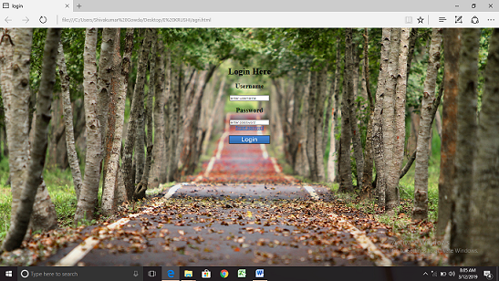

**<**html>

<head><title>login</title></head>

<style>

body{

background-image:url('shj.jpg');

background-size:cover;

}

</style>

<br><br><br><br><br><br>

<center>

<h1>Login Here</h1>

<form>

<h2>Username</h2>

<input type="text" name="username" placeholder="enter username">

<h2>Password</h2>

<input type="password" name="userpassword" placeholder="enter password"><br>

<a href="#">forget password</a><br><br>

<a href="har.html">

<img src="login2.jpg" width="150" height="30"></a>

</form>

</center>

</body>

</html>

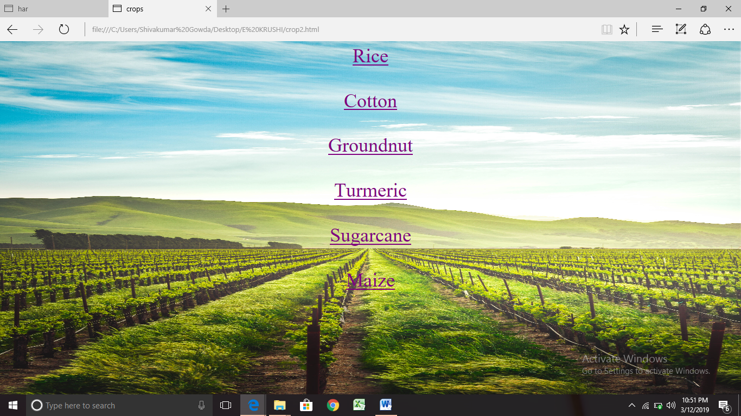

<html>

<head><title>crops</title></head>

<style>

body{

background-image:url('shd.jpg');

background-size:100% 100%;

}

</style>

<font size="20">

<center><a href="rice.html" style="color:darksiategray">Rice</a>

<br>

<br>

<a href="cotton.html" style="color:darksiategray">Cotton</a>

<br>

<br>

<a href="groundnut.html" style="color:darksiategray">Groundnut</a>

<br>

<br>

<a href="turmeric.html" style="color:darksiategray">Turmeric</a>

<br>

<br>

<a href="Sugarcane.html" style="color:darksiategray">Sugarcane</a>

<br>

<br>

<a href="maize.html" style="color:darksiategray">Maize</a></center>

<br>

</body>

</html>

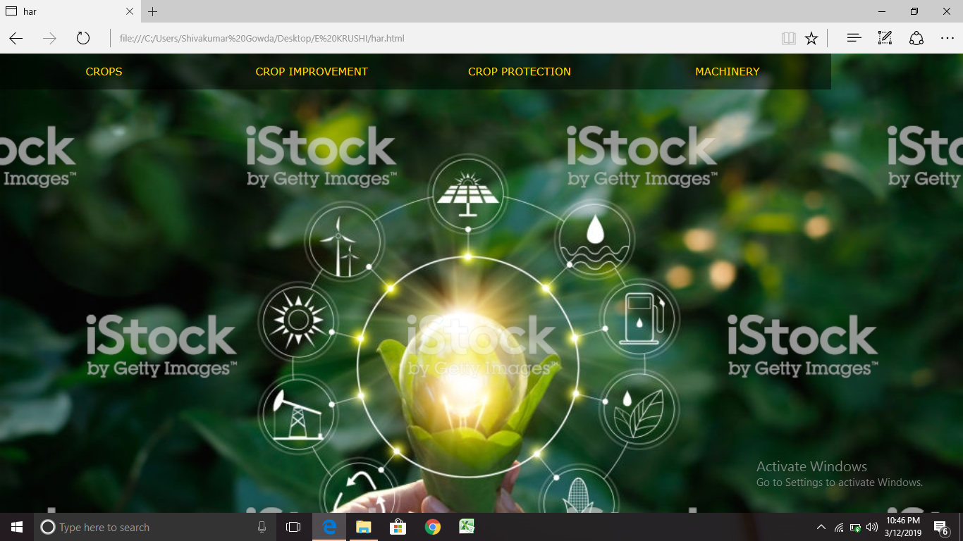

<html>

<head><title>har</title>

<style>

body{

background-image:url('shi.jpg');

background-size:cover;

font-family:verdana;

font-size:20px;

margin:0;

line-height:60px;

}

ul{

list-style-type:none;

margin:0;

padding:0;

position:relative;

overflow:hidden;

}

a:link,a:visited{

display:inline-block;

front-weight:bold;

color:white;

background-color:rgba(0, 0, 0, 0.5);

width:385px;

text-align:center;

padding:4px;

text-transform:uppercase;

text-decoration:none;

}

a:hover,a:active{

background-color:maroon;

}

li{

float:left;

</style>

</head>

<body><center>

<div id="header">

<ul><li><a href="crop2.html"><font color="gold">CROPS</font></a>

<li><a href="cropimp1.html"><font color="gold">CROP IMPROVEMENT</font></a>

<li><a href="protect.html"><font color="gold">CROP PROTECTION</font></a>

<li><a href="machine1.html"><font color="gold">MACHINERY</font></a>

</ul>

</div>

</center>

</body>

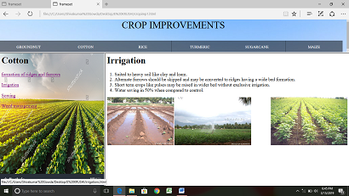

<html>

<head><title>frameset</title></head>

<frameset rows="20%,*">

<frame src="cropimp3.html" name="frames">

<frameset cols="30%,70%">

<frame name="frame2" >

<frame name="frame3">

</frameset>

</frameset>

</html>

**MACHINERIES:**

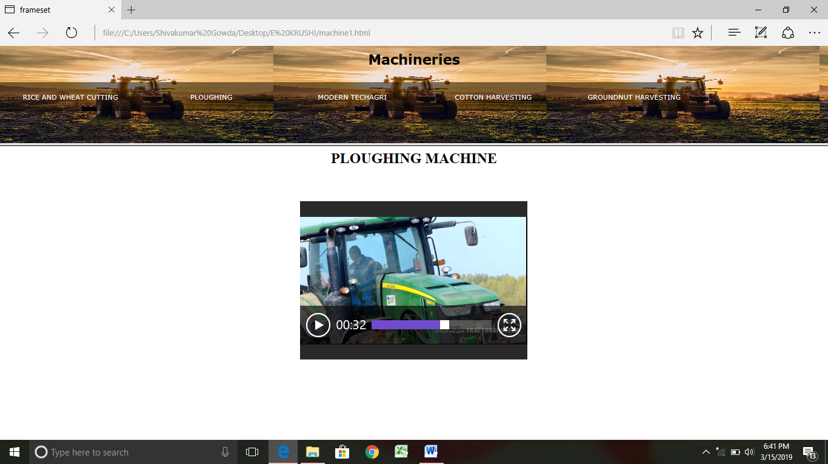

<html>

<head><title>frameset</title>

</head>

<frameset rows="25%,75%">

<frame src="machine.html" name="frames">

<frame name="frame2">

</frameset>

</html>

**CROPS:**

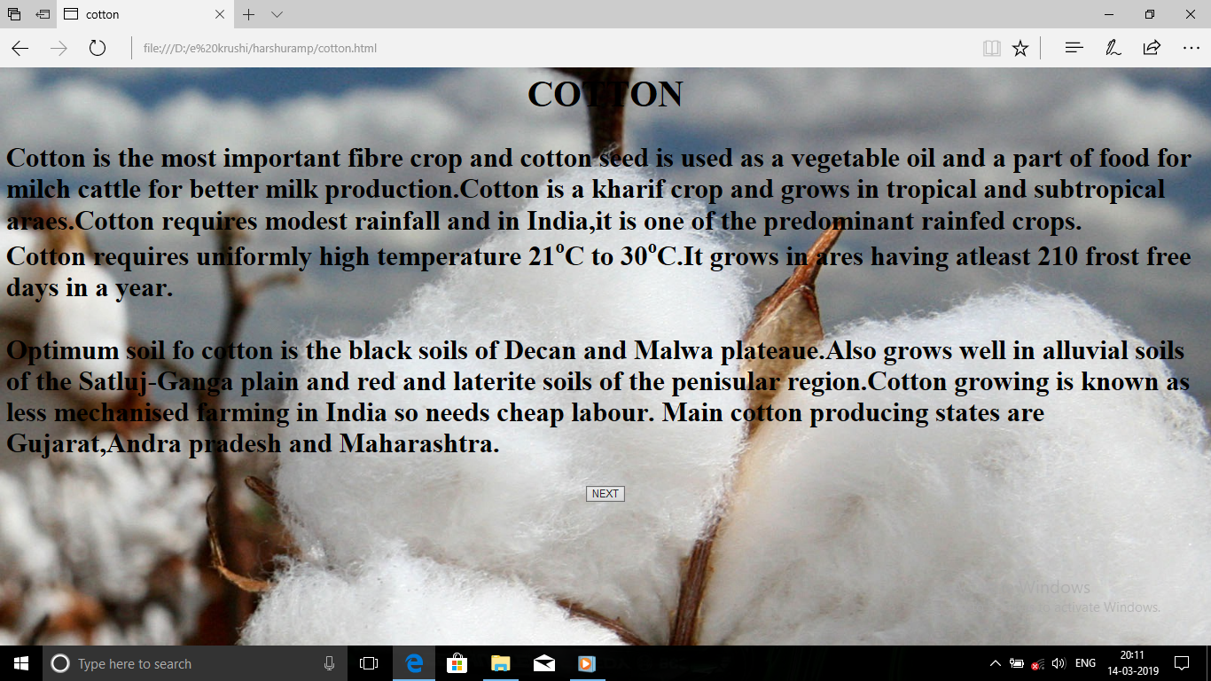

<html>

<head><title>cotton</title></head>

<body background="cotton5.jpg"><font size="5">

<center><h1>COTTON</h1>

</center>

<h2><p> Cotton is the most important fibre crop and cotton seed is used as a vegetable oil and a part of food for milch cattle

for better milk production.Cotton is a kharif crop and grows in tropical and subtropical araes.Cotton requires modest rainfall

and in India,it is one of the predominant rainfed crops.

<br>

Cotton requires uniformly high temperature 21<sup>o</sup>C to 30<sup>o</sup>C.It grows in ares having atleast 210 frost free days

in a year.

<br>

<br>

Optimum soil fo cotton is the black soils of Decan and Malwa plateaue.Also grows well in alluvial soils of the Satluj-Ganga plain

and red and laterite soils of the penisular region.Cotton growing is known as less mechanised farming in India so needs cheap labour.

Main cotton producing states are Gujarat,Andra pradesh and Maharashtra.</p></h2>

<center><a href="groundnut.html">

<input type="submit" value="NEXT"></a></center>

</body>

</html>

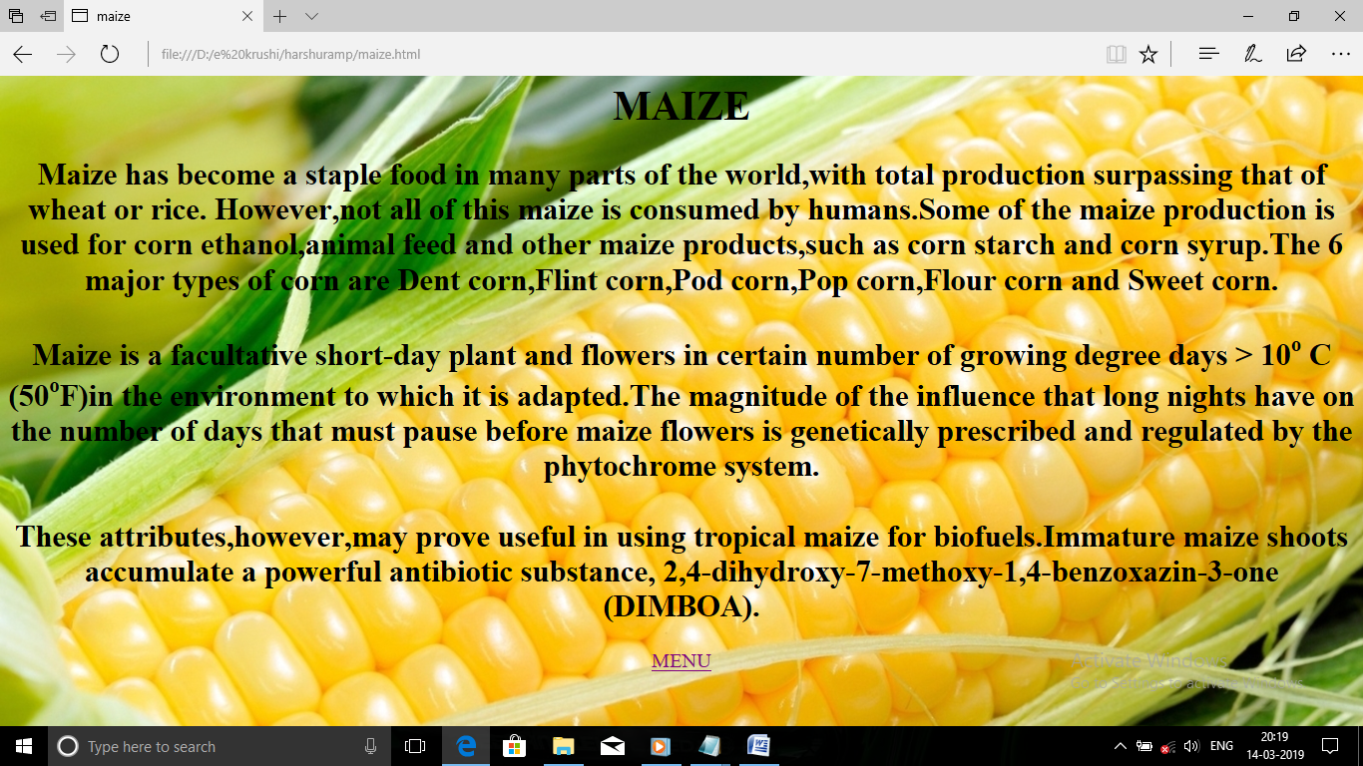

<html>

<head><title>maize</title></head>

<body background="maize1.jpg"><font size="5">

<center><h1>MAIZE</h1>

<p><h2>

Maize has become a staple food in many parts of the world,with total production surpassing that of wheat or rice.

However,not all of this maize is consumed by humans.Some of the maize production is used for corn ethanol,animal feed and

other maize products,such as corn starch and corn syrup.The 6 major types of corn are Dent corn,Flint corn,Pod corn,Pop corn,Flour corn

and Sweet corn.

<br><br>

Maize is a facultative short-day plant and flowers in certain number of growing degree days > 10<sup>o</sup> C (50<sup>o</sup>F)in the environment

to which it is adapted.The magnitude of the influence that long nights have on the number of days that must pause before maize flowers is genetically

prescribed and regulated by the phytochrome system.

<br><br>

These attributes,however,may prove useful in using tropical maize for biofuels.Immature maize shoots accumulate a powerful antibiotic substance,

2,4-dihydroxy-7-methoxy-1,4-benzoxazin-3-one(DIMBOA).</h2></p>

<a href="har.html">MENU</a>

</center>

</body>

</html>

**5. EXPERIENCE WHILE DOING THE PROJECT:**

We have completed this project with the group of three members. while doing This project we learnt lots of new thing ,from the you tube and google and our Lectures. Especially one among three of us that is hats of to your ideas my dear friend we shared our ideas and thoughts with each other that made our project look attractive. Before starting this project ,we knew few things about CSS & HTML But while doing the project we bit came to know the several options avaliable in all those.

We took lots of supports from our lecturers. Thank you all those who supported us to make our project look more better..